Kier Construction have advised that survey work is being carried out on within the Parish from week commencing 26 September.

These will be non-intrusive surveys carried out by a small team of surveyors, and any equipment that is used will be hand-held only.

Notice Number: N-305896

Scope of surveys: (Further detail enclosed below) BT1 - Bat Survey (Ground Level Tree Inspections)

Land to be accessed: LAP114373

Bat surveys
June 2022 | www.hs2.org.uk
High Speed Two (HS2) is the new high speed railway for Britain. As part of the design process, we need to carry out surveys of the local area to allow more certainty in design and increase efficiency.  What surveys are we completing?  Kier will be carrying out bat surveys on behalf of HS2. This will be a two-person team assessing the potential for trees to support roosting bats. We can do this at any time, but it’s easier to inspect trees in winter and early spring. We record features that could support bats, and record signs of current or past bat activity. Surveyors will use binoculars to examine trees from ground level, looking for rot-holes or cracks in which bats could roost. In some cases, qualified climbers may inspect individual features, to confirm their potential and record any evidence of bats.  When are we working?  If trees have moderate to high potential to support roosting bats, or where it’s unsafe to complete an initial inspection, we may need to visit two or three times in summer to watch bats emerging or returning. At least two surveyors will be at viewing points outside to count bats emerging in the evening. This will be followed by a dawn survey of bats returning to their roosts. Surveyors may also use handheld detectors to identify specific species. If trees have features likely to support hibernating bats, we may need to inspect them at least twice in January or February.  Contact our survey team  If you have any queries or concerns please contact our team at Kiersurveys@dalcourmaclaren.com  If you have a question about HS2 or our works, please contact our HS2 Helpdesk team on 08081 434 434  or email hs2enquiries@hs2.org.uk |  |  | Duration of works  These works will take place between July 2022 and December 2022  What to expect  Surveyors will contact landowners to arrange access for the surveys.  There may be surveyors in fields after dark with torches when completing some habitat surveys.  What we will do  Impact to the general public will be minimal. When a carriageway is impacted, we will be in touch with extra information.  Questions about surveys  If you have a question about these surveys, please email hs2surveys@kier.co.uk

Tree tagging
In order to support the study of roosts and make sure suitable bat habitat is protected, trees may be tagged to ensure further surveys are conducted on the correct tree. This is not damaging and is used by the Bat Conservation Trust for the same purpose.

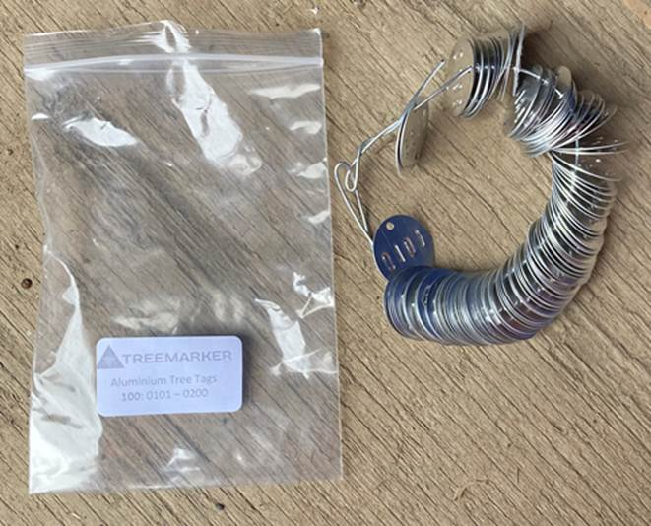

Covid-19
We are working in line with Government and Public Health England (PHE) advice on working safely during the pandemic. For all events and engagement, we will carry out a risk assessment and put in place control measures to manage the risk of Covid-19 to the public and our staff. If you have any questions about this, please contact our Helpdesk to find out more. The health and safety of our workforce and the communities we affect is our key priority.

