**INGESTRE & TIXALL NEWS**

November/December 2021

INGESTRE WITH TIXALL PARISH COUNCIL

Contents

**Page 2/3** – Latest updates from HS2 & other Parish News

**Page 3** – Village Hall update and Church News

**Pages 4/5** – Local information of interest

**Pages 5/13** – Update on Cannock Chase

**Page 13** – Christmas wishes from your Parish Council

**PARISH NEWS**

**Parish Council Meetings:** in line with the latest Government advice, all Parish Council meetings will take place, face to face, in Tixall Village Hall.

. **Latest updates on HS2**

**Notice of surveys on Tixall Road, Mill Lane and Hoo Mill Lane, near Great Haywood.** Keir, working on behalf of HS2 will be carrying out ground penetrating surveys to help them identify the location of buried utilities, like Gas, Electric or Water. The duration of these works are as follows: 22 – 23 November; 16 December – 5 January 2022, Monday to Friday, between the hours of 8am – 5pm. More details can be found on the attached Notice.

**Thursday, 25 November 2021, 6.00pm.** HS2 in Focus: An introduction to the Phase 2a environmental programme. HS2 is hosting a ‘meet the expert’ online engagement event covering how HS2 is mitigating the environmental impact of the project. During the session they will explain how the environmental survey programme and some of the key ways they are protecting, enhancing and creating new wildlife habitats across the Phase 2a route. There will also be the opportunity to ask any questions you may have.

The session will be running via Microsoft Teams Live Events, which is a free to use online platform. To join the event, you can register online via the platform EventBrite. You will then receive confirmation and the details to join the event.

[**Please click here to register for the event**](http://www.eventbrite.co.uk/e/hs2-in-focus-an-introduction-to-the-phase-2a-environmental-programme-tickets-200771431757)

You can also find the event listed on the HS2 website at [www.hs2.org.uk/events](http://www.hs2.org.uk/events)

**Other Parish News**

**Tixall Broadband.** The Parish Council is continuing to liaise with Openreach on this project and will provide an update as soon as possible.

**Staffordshire and Worcestershire canal towpath improvements.** Discussions with HS2 and the Canal and River Trust on this project are continuing. Unfortunately, there has been a delay in the commencement date for the work**,** however, all parties remain fully committed to the delivery of this project and further updates will be provided in due course.

**Parish Newsheet.** The Parish Council is keen to increase the electronic circulation of the Newsheet to residents within the Parish. However, to ensure we comply with current Data Protection legislation, we are unable to contact anyone else within the Parish (whose email contact details we have obtained for other purposes, i.e., Tixall Broadband project) to ask if they would like to receive a copy of the Newsheet. Therefore, if you are aware of any residents who may be interested in receiving this Newsheet, please ask them to email the Parish Clerk asking to be added to the Parish Newsheet distribution list.

**Village Hall Update**

**Tixall & Ingestre Village Hall 100-Club update**

The 100-club has had the following draws:

**October:**

* 1st prize of £25 was won by Tony Young
* 2nd prize of £10 was unsold
* 3rd prize of £5 was won by Sue Haenelt. Sue has donated her prize to Ingestre Church.

**November:**

* 1st prize of £25 was won by Gill Broadbent. Gill has donated her prize to the Village Hall.
* 2nd prize of £10 and 3rd prize of £5 were both unsold

**The Village Hall has been well restored and decorated, it has new blinds and a new floor finish. It is now fully back in use and taking bookings – please contact Sheila Sindrey if interested on 01785 663767.**

**Tixall Church Coffee mornings, 10.00am – 12.00pm, every 2nd Monday**

**Phone box has been restored – it is now a Book and Seed Exchange.**

**Church News**

**Church Services in Ingestre and Tixall during November and December:**

**Christmas Services in Ingestre**

Carol Service - 15th December 7:30pm

Midnight Christmas Service - 24th December 11:30pm

Next Service 9th January 11:15am

Service on 2nd and 4th Sundays 11:15am

**Christmas Services in Tixall**

Carol Service - 19th December 6pm

Christmas Day Service - 25th December at 9am

Next Service 2nd January 11:15am

Services on 1st and 3rd Sundays 11:15am.

For more information contact the church office 01785 253493

**LOCAL INFORMATION OF INTEREST**

**Your Local Police Officers:**

Please see attached poster for details of the PCSO’s who cover the area and the correct methods to use, when contacting them.

**Seen a problem with the roads??** It is simple and easy to report any issues with Staffordshire highways to Staffordshire County Council by logging onto the ‘MyStaffs’ App and reporting any issues directly to the Highways team. Whilst the Parish Council are interested in being made aware of any issues, it is often quicker and more effective if residents report any issues directly to Staffordshire County Council themselves.

**Did you know that you can use the same App to report non-urgent matters to Staffordshire Police?**

To use this service, simply type in ‘MyStaffs’ into your internet search engine and then click onto MyStaffs App, which you will need to download. If you are an iphone/ipad user you can download the App via an i/Tunes account or if you have an android phone/tablet you can download the App via Google Play.

You may also wish to access the link here: [myStaffs - Staffordshire County Council](https://www.staffordshire.gov.uk/MyStaffs-App/MyStaffs-App.aspx)

## **Fully Funded Suicide Prevention Training**

Sadly, two thirds of people who die by suicide haven't accessed any mental health support.

That's why, we need ordinary people (like you!) to be more aware of the signs someone is at risk of suicide and able to help them get the support they need.

We're offering individuals and not-for-profit clubs, groups and organisations, who are active in our communities, a limited number of fully funded places on our suicide prevention training.

The training will help you gain the skills and confidence you need to help someone who is at risk of suicide.

Developed by North Staffordshire Mind, the half-day online training course has been designed to:

* Help you recognise signs that someone may be at risk
* Train you to use a simple 4 step suicide intervention
* Share information with you about local support services

***Apply for a place on the training***

Complete and submit this [form](https://forms.office.com/Pages/ResponsePage.aspx?id=TdGsJLuS1kS7qO2z0DgTzZahgF0iiwtNtI1STVnS3vZUNDQ4TkMyTUZRUllUUU9ZR0tBTEZNRlpKNC4u&utm_medium=govdelivery&utm_source=email) to apply for your place. We expect the training to be popular and places are limited, please submit your form as soon as possible to avoid disappointment

## About #TalkSuicide

#TalkSuicide is a new campaign, developed by Staffordshire County Council working in partnership with Stoke-on-Trent City Council, local hospitals and NHS community services.

The campaign aims to bring individuals, organisations and businesses together to help prevent suicide in Staffordshire and Stoke-on-Trent. We believe by bringing people together, the small things we all do can make a BIG difference

## We need more people like you!

Together we can do more and reach further, that’s why we’re aiming to get 1,000 people across Staffordshire and Stoke-on Trent to join us.

It’s a lot to ask, but we believe that 1,000 people in our communities talking about suicide and gaining the skills to save a life is vital, now, more than ever.

Please share this [link to sign](https://public.govdelivery.com/accounts/UKSTAFFORDSHIRECC/signup/18007) up to the campaign, with your friends, family and colleagues - anyone can join us, whether they're an individual, organisation or business.  And together we can help prevent suicide in Staffordshire and Stoke-on-Trent

## Find out more

* [About #TalkSuicide](http://www.staffordshire.gov.uk/TalkSuicide)
* [Apply for funded training place](http://www.staffordshire.gov.uk/TalkSuicide)
* [Sources of help (local and national)](http://www.staffordshire.gov.uk/TalkSuicideSupport)

## Useful links

* [Zero suicide alliance](https://www.zerosuicidealliance.com/?utm_medium=govdelivery&utm_source=email)
* [Mind](https://www.mind.org.uk/information-support/types-of-mental-health-problems/suicidal-feelings/about-suicidal-feelings/?utm_medium=govdelivery&utm_source=email)
* [Samaritans](https://www.samaritans.org/how-we-can-help/if-youre-worried-about-someone-else/myths-about-suicide/?utm_medium=govdelivery&utm_source=email)

[Need urgent help?](https://www.staffordshire.gov.uk/Advice-support-and-care-for-adults/Keeping-well-and-staying-healthy/Mental-health.aspx?utm_medium=govdelivery&utm_source=email)

**Community Safety Flash**

Kitchen fire safety – What are the hazards? See leaflet attached, to help reduce the risk of this happening in your home.

**Managing Cannock Chase – Update November 2021**

Over the last few years Staffordshire County Council, working with RSPB and Natural England, has been discussing and developing options for managing open habitats on Cannock Chase. You kindly took time to give your views on these options and asked to be kept informed on progress.

The options included types of management that have been used for many years on the Chase, such as cutting and controlled burning of heather, cutting and spot treating trees and scrub, and cutting and spraying bracken. They also included reintroducing grazing with livestock, which was the traditional way the Chase was managed before the Great War.

This email is to update you on what’s happening, and the work planned over the coming months. General information can be found [here](https://www.staffordshire.gov.uk/environment/Environment-and-countryside/Managing-Cannock-Chase/Overview.aspx).

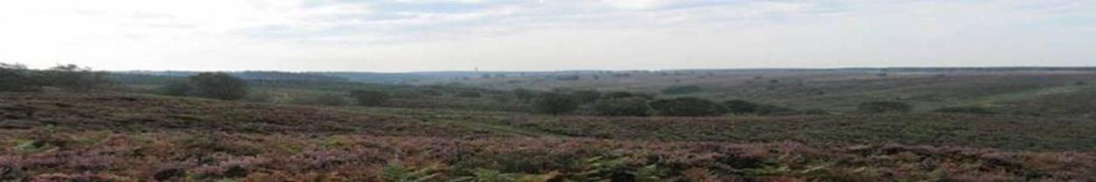

**Great start to grazing**

Our pilot conservation grazing scheme got off to a great start this year. From August to early November, six Hereford cattle owned by a local farmer grazed at Moors Gorse, a small area of the country park near the visitor centre.  Conservation grazing uses low numbers of cattle to mimic the action of wild herbivores that would once have roamed the UK but are now extinct. Grazing is vital for getting the right balance of plants, keeping vigorous plants under control and allowing less competitive plants to thrive. This helps provide the best conditions to support rare and specialised heathland wildlife.

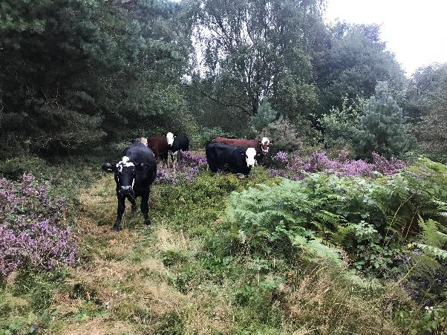

The cattle spent the first few weeks in the smaller top area of Moors Gorse, getting used to the layout of the site and location of the water supply.   This area has a footpath around it so it gave visitors to the site a great chance to see them and ask questions of staff who were checking on them daily, along with the grazier.  Many of the regular dog walkers have said how they look for the cattle each morning to check they are all ok and they have started to notice the overgrown vegetation slowly being opened up by the animals grazing. Once they were familiar with the site, the cattle went into the larger lower area. There are now patches in the larger vegetation that have been trampled and opened up to show the rare heathland plants that were struggling beneath.   The cattle have grazed their way across the site eating a variety of vegetation, even bramble.

The fence around the grazing area has been carefully designed to keep the cattle in but to allow other animals to move freely around the site and we have some great footage of deer and other wildlife all using the railed areas to go about their business – [click here](https://www.youtube.com/watch?app=desktop&fbclid=IwAR16IpA-aP5fvmWUN4tre695jFT2VlL1Sb9UAFWwy3G3C-a74rKP_KhXVis&v=-RtNpn0IA7s&feature=youtu.be) to see this in action. Now that the cattle have left for the winter, the water supply will be drained down and turned off. We will carry out some winter work with volunteers to manage some of the more overgrown areas the cattle didn’t have time to get into. Then the cattle will come back to the site in the spring – notices will be put up to let people know when they are on site.

We would like to thank our visitors, particularly those who regularly use this part of the site, for their great support for the scheme. We have had really positive feedback and know that many people looked forward to seeing the cattle and were helping to keep an eye on them. Next spring we will be training up some volunteers to do this more formally.

**Keeping our Heather Healthy**

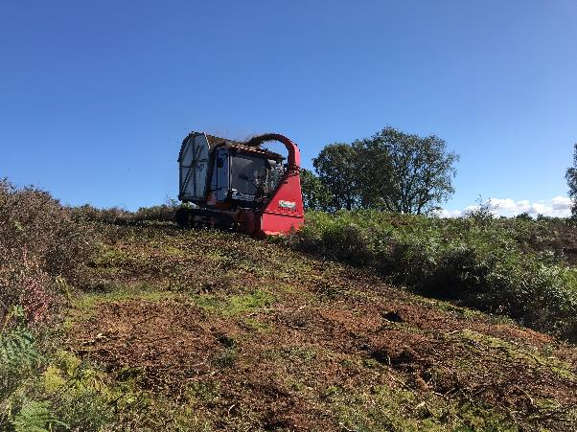Heather is an important part of the heathland flora but it requires some management to keep it healthy. Ideally a heathland will have areas of heather at different ages, as each growth stage supports different wildlife and it ensures there will always be new growth coming through. Gaps in the thick patches of mature heather also allow space for other heathland rarities to flourish such as bilberry, cowberry and heath bedstraw.

This year we have used some new machinery to do this work rather than a conventional tractor and baler.   The new Soft-Trak machine we used has a very low ground pressure so it won’t cause any damage to the ground, especially as some of the Chase has archaeological remains hidden under the soil.   This machine operates on tracks and is very stable so it can cut heather on steep slopes and wet ground without risk of getting stuck or becoming unstable.   It also does everything in one operation, cutting and collecting the cut material at the same time. We chose some challenging areas to put the machine through its paces, and after this successful trial we are considering how we use this to best effect going forward.

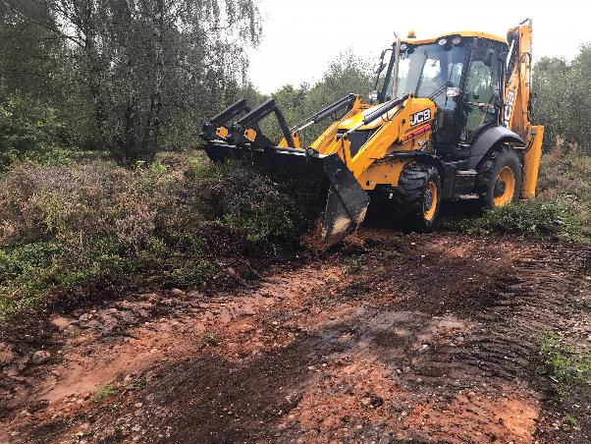

**Supporting Pollinators (and other insects!)**

You may have noticed some scrapes and banks appearing in the heathland around the country park. These have been created for bees, wasps and beetles which like warm exposed soil for nesting, basking and hunting. By creating these areas of habitat, we will increase the number of invertebrates on the site and this in turn helps ensure we have plenty of pollinators for heathland plants and food for birds and other species. The scrapes also provide great basking areas for reptiles like common lizards and adders.

The scrapes have to be carefully planned – they are best created on south-facing slopes so they warm up to create the perfect microclimate for insects, but they also need to avoid any archaeological features and sit well in the landscape – so several of our environmental specialists and AONB team members are involved in planning them. The areas have been designed to provide slightly different conditions for different species. While working, rangers noted signs that the scrapes put in last year were already being used and these will continue to be monitored to see whether they need any additional work

**Restoring our rivers**

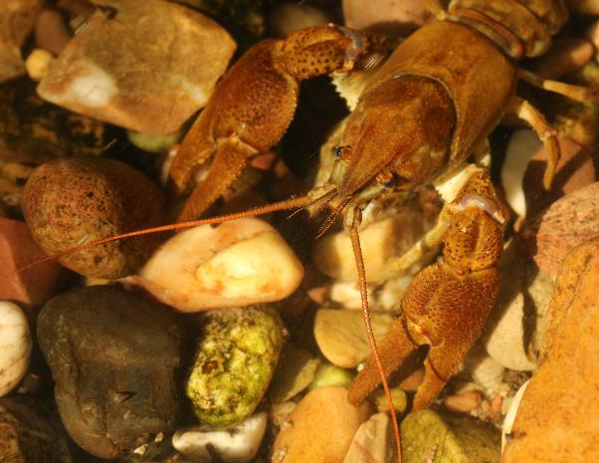This winter, SCC and Staffordshire Wildlife Trust are teaming up to carry out habitat works to benefit some rare species along the watercourses through the site. The main activity will be the coppicing (cutting the trees near the base) of alders and birch trees in Sherbrook Valley. This will open up parts of the canopy to let more light in at ground level. The wood from the coppicing will be placed into the stream, stream margins and wet woodland areas to provide crucial deadwood habitat for white-clawed crayfish, brook lamprey, brown trout, the logjammer hoverfly and the small pearl-bordered fritillary butterfly. Although the coppicing can sometimes appear quite intense it's important to remember that this traditional technique does not kill the trees and that they regrow from the sawn-off stumps. In many areas, you can see that the trees have been coppiced in the past.  This wildlife habitat enhancement project is being funded by Severn Trent through their Great Big Nature Boost. *(Image – white clawed crayfish by © Nick Mott Staffordshire Wildlife Trust)*

**Winter Scrub Management**

During the winter, outside of bird breeding season, we will be tackling some of the scrub growth around the site to maintain it at the right level. Some scrub is great for wildlife, but without management it will take over and crowd out the heathland plants, reducing biodiversity. Opening areas up helps create the right conditions for some of our rare species, including small pearl bordered fritillary butterflies. It also helps ensure that the roots from trees and shrubs don’t harm archaeological features.

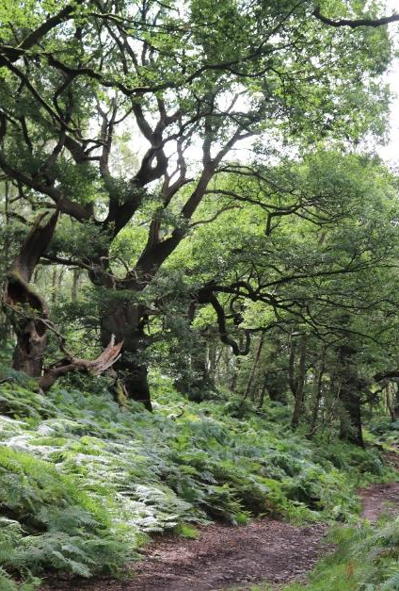

**Protecting Brocton Coppice**

During the winter we will be carefully carrying out “halo thinning” of the birch trees around the veteran oaks in Brocton Coppice, to allow more light to the canopy. We do very little work to the oaks themselves, as these trees are very vulnerable. In fact, you may have seen a number of signs around the Coppice asking people not to cycle or ride horses on the informal paths. This is because unfortunately the ancient oaks – some over 600 years old -  are having their root systems damaged by compaction of the soil and direct damage to the roots themselves. Sadly, people have also been creating unofficial bike trails with jumps which cause huge damage to the site, and some people have even vandalised the trees themselves –both things we are working with the police to tackle since this damage can constitute a criminal offence in a protected area. We will be doing some further work to reroute informal footpaths away from vulnerable trees to keep both people and trees safe.

We are also doing further work to look at the broader management of the coppice. Like many ancient woodlands in England, there is an age gap in the trees, with many several hundred years old, and then some quite young trees planted more recently. The gap in the middle means that, without careful management, some of the rare wildlife that depends on the trees’ later life stages could run into problems. This is why we need to keep the trees alive for as long as possible, to give us time to plug the gap. We will start planting some of the oak saplings from acorns we have collected and nurtured. However, we are also looking at ways to connect areas of ancient and veteran trees around the Chase so that beetles and other wildlife can move around more easily and find trees at the right life stage for what they need. This might include artificially “veteranizing” some younger trees, and creating beetle boxes that act as stepping stones through the site. It’s amazing to think that about a third of the biodiversity an oak tree supports lives on the tree when it is decaying. But continuity is key – these species are not always very mobile so they need an ongoing supply of decaying wood nearby to keep them going.

**New play area open!**

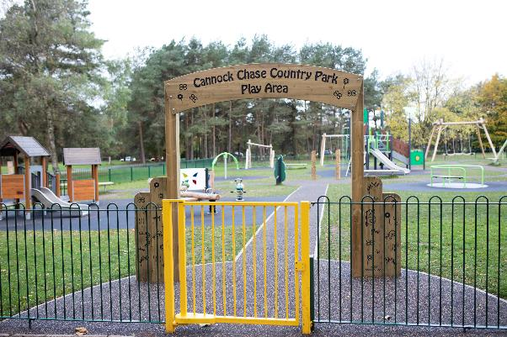We are delighted that our new play area is open at Marquis Drive, providing a great new facility for children. The play area officially opened in October and has been funded by the European Agricultural Fund for Rural Development as part of the ‘Staffordshire Countryside Explorer Project’.  The project was also made possible through funds from country park car parking fees.

**Explore the Chase2Water Trail**

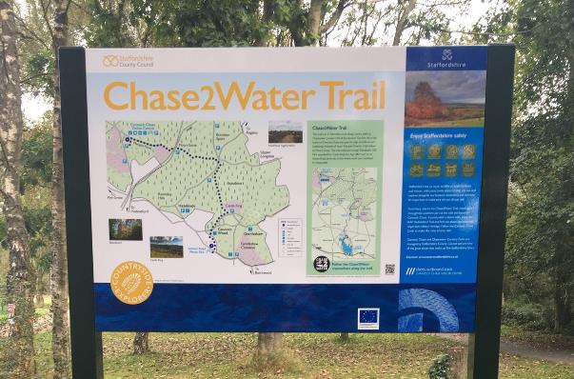Another part of Countryside Explorer is a new

7 mile linear walking route – the Chase2Water Trail. The trail links Cannock Chase Visitor Centre to Chasewater Country Park, heading through some great areas for wildlife and heritage along the way. The route is waymarked and features new interpretation and map panels. A route guide leaflet is in development and will be available from Marquis Drive Visitor Centre very soon! The Staffordshire Countryside Explorer project has seen improvements made at three of our country parks - Cannock Chase, Chasewater and Greenway Bank in the Staffordshire Moorlands where you can find a new heritage trail around the park.

**Car Park Maintenance**

We will be undertaking some basic repairs to car parks around the Country Park over the coming months. This may involve some short term closures just while the work is carried out – please follow any signs on site for your safety and to make sure the work can be completed.

**Apples on the Chase**

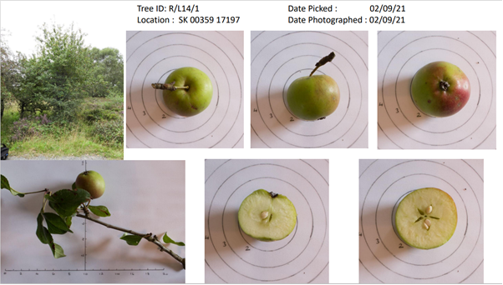The Chase Through Time volunteer group have been very busy this autumn locating and recording the apple trees on the Chase. The ‘Apples on the Chase’ project, which is funded by the Cannock Chase AONB Sustainable Development Fund and supported by the Friends of Cannock Chase and the County Archaeologist, was developed to try to help us better understand why we have so many apple trees on the Chase, where they are located, what they were used for, and how old they are. As most of these trees are found in and around the two former Great War training camps, we think many of them were probably planted by the trainee soldiers near their barrack huts, whilst others may have self-set in the area around the kitchen or latrine blocks, or may have grown where the core was dropped after the apple was eaten.

The first phase of the project has recently been completed and over 90 fruit trees have been identified across both the former Rugeley and Brocton camps. Each tree/fruit has been recorded and the volunteers are checking them against the National Fruit Collection apple database. A number of apples have been sent to specialists for possible identification, whilst others, which seem to be from trees which pre-dated the camps, have been sent for DNA analysis to see if they are a rare variety or perhaps a special Cannock Chase cultivar.

The completion of the project will be celebrated by planting some apple trees near the Great War Hut at Marquis Drive.

*(Image - An example of apple photo record sheet developed by the Chase Through Time Volunteers © Colin Evans)*

**Conserving an RAF Hednesford wall at Moors Gorse**

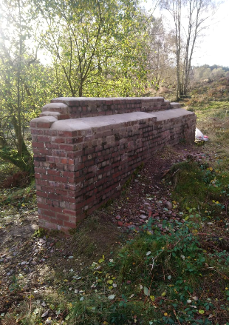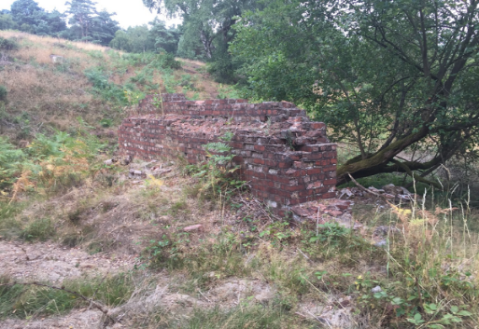Conservation works have recently been completed on a historic brick wall at Moors Gorse. It is believed that the wall formed part of RAF Hednesford’s notorious assault course, and is located near ‘Kitbag Hill’ which refers to the steep ascent from Moors Gorse up Marquis Drive to the camp on which new arrivals had to carry their kit. The work, which was carried out by Ian Fisher, a conservation bricklayer, and funded as part of Staffordshire County Council’s Cannock Chase Countryside Stewardship Scheme, included repointing and capping works, in addition to targeted brick replacement. This work should ensure that the wall, which is one of the few surviving upstanding remains of RAF Hednesford, will be protected from the elements for many years to come.  *(Left image – before restoration, right image – after restoration)*

**A Lens on the Past**

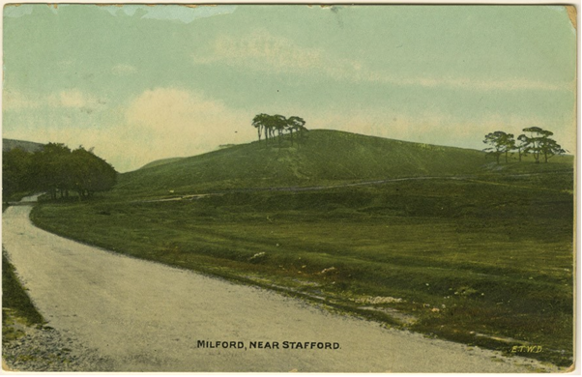Did you know that there are photographs of Cannock Chase dating back to at least 1873? We thought it would be interesting and quite useful to examine historic photos of the area to see how much the landscape of the Chase has changed over the past century or so. The ‘A Lens on the Past’ project, which is funded by the Cannock Chase AONB Sustainable Development Fund, has seen the Friends of Cannock Chase and the Chase Through Time volunteers search through numerous historic photos and choose a number of views and scenes to be replicated by Steve Welch, a professional landscape photographer.

The photographer has tried as best as possible to capture the same view from the spot that the original photographer took theirs. The initial results have been fantastic and have shown how much the landscape of the Chase has changed over the years, particularly given the impact of forest/woodland creation since the Great War, whilst also demonstrating how the special character of this lowland heathland landscape has endured.

This project has already provided a useful insight into the scale of landscape change on the Chase over the past hundred or so years, and the results will be shared on a dedicated page on the Cannock Chase AONB website when it is concluded early next year.

*Top image - Milford Common looking towards of Lichfield. Photograph taken just past the Barley Mow, 6th August 1907 (Courtesy of Jake Whitehouse)*

*Lower image - The same view of Milford Common today (© Steve Welch)*

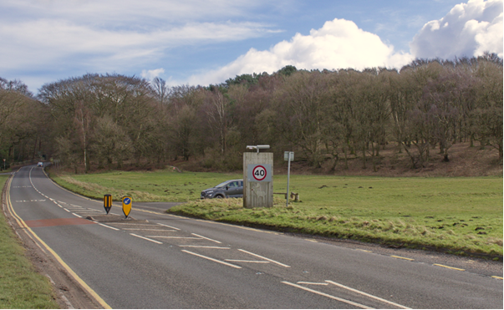

**Follow the code and help to protect Cannock Chase**

The Cannock Chase AONB Partnership, SAC Partnership, public and charitable landowners, emergency services and local authorities are calling on local communities and visitors to help care for Cannock Chase by following a new Code.

The code features 12 ways that visitors and residents can help care for Cannock Chase:

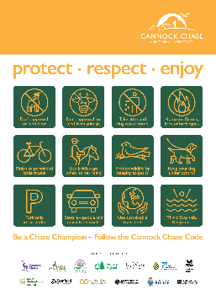

* Don’t approach or feed deer
* Don’t approach or feed farm animals
* Take litter and dog waste home
* No naked flames, fires or barbeques
* Only use permitted cycle tracks
* Use bridleways when horse-riding
* Protect wildlife by keeping to paths
* Keep your dog under control
* Park only in car parks
* Beware – people and animals on roads
* Use sustainable transport

Think! Stay safe. Keep out (of water)

The organisations backing the Cannock Chase code include the AONB Partnership, SAC Partnership, Cannock Chase Council, Forestry England, Lichfield District Council, West Midlands Ambulance Service, National Trust, South Staffordshire Council, Stafford Borough Council, Staffordshire County Council, Staffordshire Fire and Rescue Service, Staffordshire Police and Staffordshire Wildlife Trust.

The code will be rolled out as opportunities arise, and will start to feature on on-site interpretation panels, promotional materials, in visitor centres and online.

Cannock Chase is one of England’s finest landscapes – a beautiful yet fragile place with rare wildlife and important cultural heritage.  Area of Outstanding Natural Beauty (AONB) status ensures this outstanding landscape has the highest level of protection to conserve and enhance it for the nation and for present and future generations to enjoy.

The Parish Council would like to take this opportunity to wish all the residents of Ingestre and Tixall a very happy and peaceful Christmas and New Year.



*Every endeavour has been made to ensure information contained in this Newsheet is correct at the time of production.*